EE446 – LAB5 – PRELIMINARY WORK – FA1 – KAAN FURKAN ALTINOK – 2030021

1.2



1.2.1

1 & 2)



3) Control Unit:

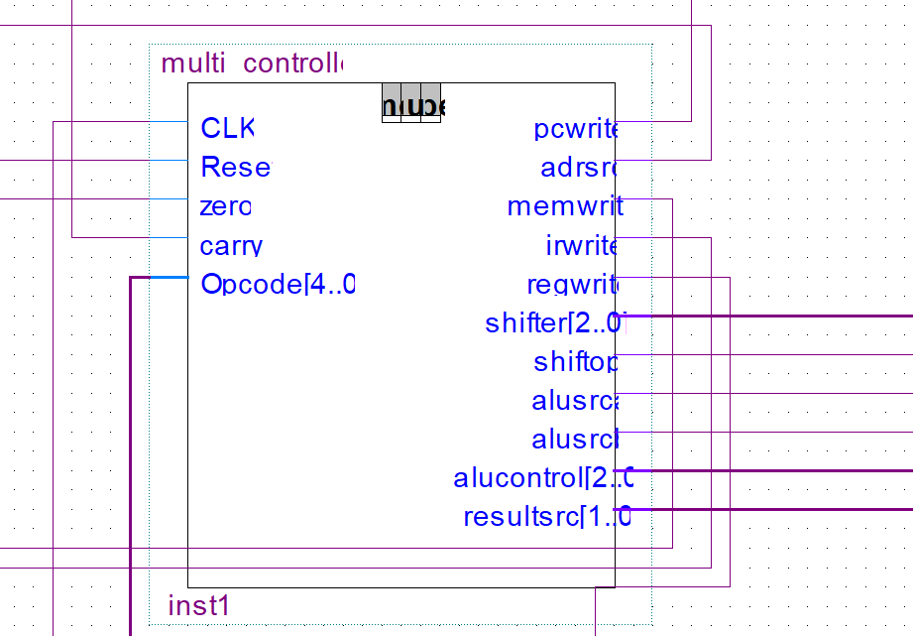

My controller and datapath is the same as LAB4 since it was a fully working CPU.

4) Testbench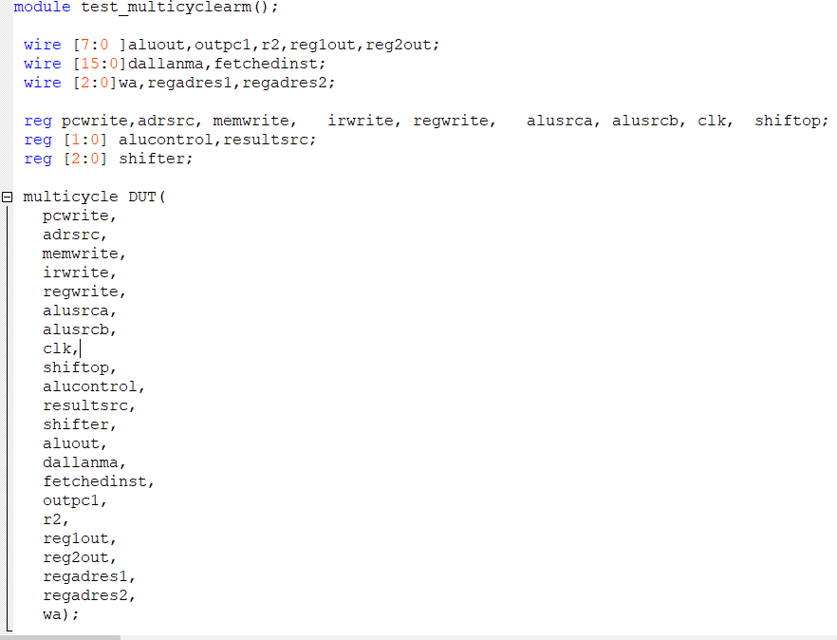

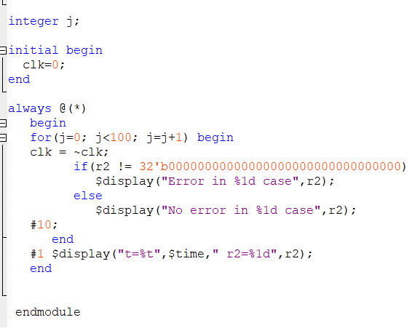

1.2.2.

All Subroutines in one program:

data[0]<=16'b1000101100001010; // branch w.link to subr.1 (Link register is R3)

data[1]<=16'b1000101100010101; // branch w.link to subr.2

data[2]<=16'b1000101100011000; // branch w.link to subr.3

data[3]<=16'b1100101100000000; //finish

data[10]<=16'b1100001000000001; // 16bit instruction or 8 bit data

data[11]<=16'b1100001100000100;

data[12]<=16'b1100010000000011;

data[13]<=16'b1100010100000011;

data[14]<=16'b1100011100000011;

data[15]<=16'b0000001001001100; //add array numbers and store them

data[16]<=16'b0000001001010000;

data[17]<=16'b0000001001010100;

data[18]<=16'b0000001001011100; // end

data[19]<=16'b1000101100000001; // branch link return

data[21]<=16'b1100001000101010; //2s complement begin

data[22]<=16'b0000101000101000; // end

data[23]<=16'b1000101100000010; // branch link return

data[24]<=16'b1100001000000000; //determine odd/even and shift begin

data[25]<=16'b1100001100000000;

data[26]<=16'b1100001000000111;

data[27]<=16'b1100001100000111;

data[28]<=16'b0101001001000000;

data[29]<=16'b0101001001000000;

data[30]<=16'b0101001001000000;

data[31]<=16'b0101001001000000;

data[32]<=16'b0101001001000000;

data[33]<=16'b0101001001000000;

data[34]<=16'b0101001001000000;

data[35]<=16'b1100001000000111;

data[36]<=16'b1001100000101100; // b if zero

data[37]<=16'b0110001001000000;

data[38]<=16'b0101001001000000;

data[39]<=16'b0101001001000000;

data[40]<=16'b0101001001000000;

data[41]<=16'b0101001001000000;

data[42]<=16'b0100101001000000; // end

data[43]<=16'b1000101100000011; // branch link return

data[44]<=16'b1100001000000111;

data[45]<=16'b0110001001000000;

data[46]<=16'b0100001001000000;

data[47]<=16'b0100001001000000;

data[48]<=16'b0100001001000000;

data[49]<=16'b0100001001000000; // end

data[50]<=16'b1000101100000011; // branch link return

END OF PROGRAM

Results:

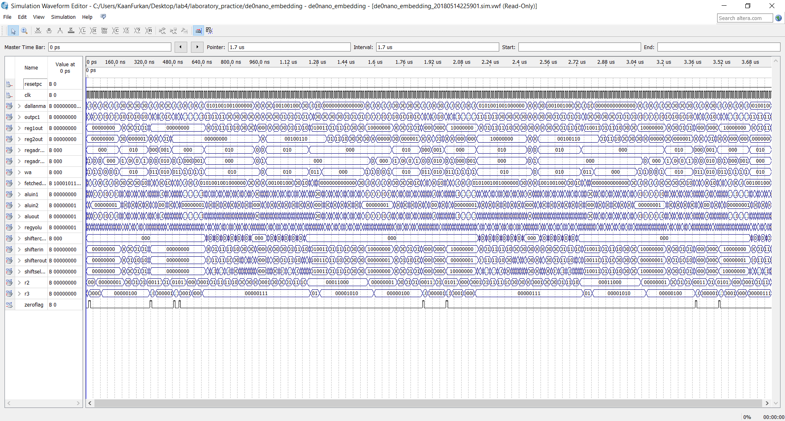

Fully working.